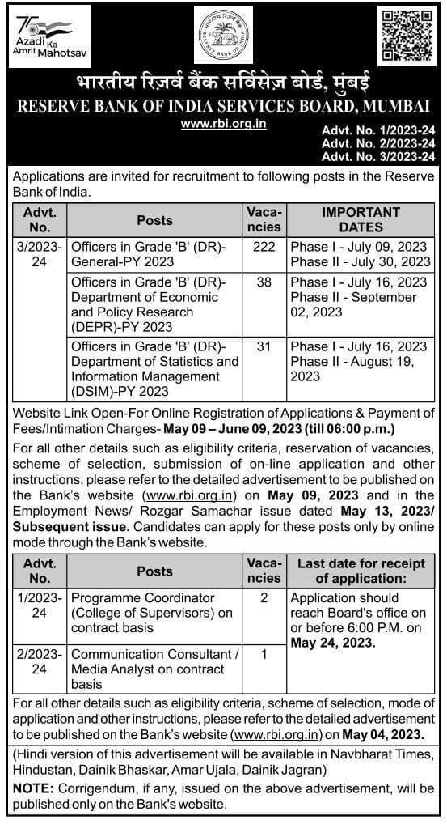
RBI Grade B notification 2023
The Reserve bank of India has released the RBI Grade B notification 2023 pdf short notice.
For this RBI Grade B recruitment 2023 notification pdf, there is tough competition.
The official RBI Grade B Notification 2023 pdf contains complete information on the vacancies, the application process, the selection process, and other data.
The RBI Grade B notification 2023 expected date is a topic of interest for applicants.
If you want to learn more about the RBI Grade B Apply Online 2023 procedure, the RBI Grade B notification 2023 pdf expected date, the RBI Grade B age limit 2023, the qualifications, etc., please read this page.

